U-frames

🧱 What Is U-frames?
# Source: Chatgpt (GPT‑5 Mini) at [12/14/2025]
U-frames in HDLC (High-Level Data Link Control) are Unnumbered frames that are primarily used for link control and management. Unlike I-frames (which carry user data) or S-frames (which handle flow/error control), U-frames are mostly used to establish, maintain, and terminate the connection.

HDLC Frame Types (Quick Context)
# Source: Chatgpt (GPT‑5 Mini) at [12/14/2025]
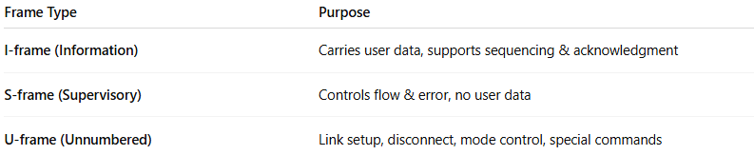
Frame Type | Purpose
I-frame (Information) | Carries user data, supports sequencing & acknowledgment
S-frame (Supervisory) | Controls flow & error, no user data
U-frame (Unnumbered) | Link setup, disconnect, mode control, special commands

What U-frames Do
# Source: Chatgpt (GPT‑5 Mini) at [12/14/2025]
- Set up and terminate a connection
- Change link modes (normal, asynchronous balanced mode, etc.)
- Perform link tests or diagnostics
- Support special control functions
U-frames can operate independently of sequence numbers, which is why they are called “unnumbered.”

Common U-frame Commands
# Source: Chatgpt (GPT‑5 Mini) at [12/14/2025]
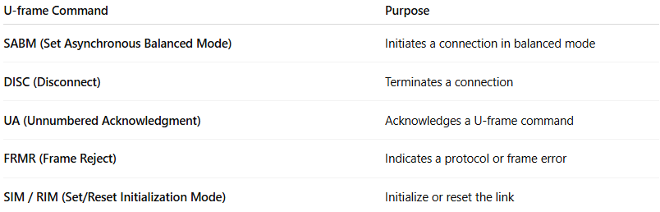
U-frame Command | Purpose
SABM (Set Asynchronous Balanced Mode) | Initiates a connection in balanced mode
DISC (Disconnect) | Terminates a connection
UA (Unnumbered Acknowledgment) | Acknowledges a U-frame command
FRMR (Frame Reject) | Indicates a protocol or frame error
SIM / RIM (Set/Reset Initialization Mode) | Initialize or reset the link

Structure of a U-frame
# Source: Chatgpt (GPT‑5 Mini) at [12/14/2025]
- Address field – destination station
- Control field – indicates the type of U-frame and command
- Optional Information field – rarely used
- Frame Check Sequence (FCS) – error detection
Unlike I-frames and S-frames, U-frames are flexible and lightweight, designed for management rather than data transport.

Key Points
# Source: Chatgpt (GPT‑5 Mini) at [12/14/2025]
- U-frames do not require sequence numbers
- Mostly used for link establishment, termination, and control
- Can operate independently of data flow

In Simple Terms
# Source: Chatgpt (GPT‑5 Mini) at [12/14/2025]
U-frames are the “command and control messages” of HDLC: they set up connections, tear them down, and handle special link functions, without carrying user data.

